**Recipe # – iPhone Wireframe**

Author:

Date: 29/02/2012

Contents

II. Introduction 4

A. Purpose 4

B. Document Conventions 4

C. Intended Audience and Reading Suggestions 4

D. References 4

III. Overview 5

IV. Product Features/Requirements 6

A. General Requirements 6

B. Functions/Features 6

1) Login 6

2) Register 8

3) Main screen 9

4) Search Result Page 11

5) To Do Page 12

6) Feed page 13

7) Recipe page 14

8) User Profile Page 16

9) Following user list and follower list Page 17

10) Comments Page 18

11) Ingredient Page 20

12) Direction Page 21

13) My Recipe Page 21

14) Add New Recipe/Recipe Submit 23

~~15)~~ ~~Recipe Ingredient and Step List~~ 24

16) Add Ingredient 25

17) Add Step 26

18) Web Administration 27

# Introduction

## Purpose

This document formalizes the requirements for the iPhone Recipe App.

## Document Conventions

Each requirement is associated with a priority "low", "medium" or "high". All requirements, by default, have priority "high".

Overview about iPhone Recipe App is presented in the first part of the document, and then all features and functions are analyzed in detail later.

## Intended Audience and Reading Suggestions

This document is intended for:

* Development team: in order to be sure they are developing the right project that fulfills requirements described in this document.
* Project Owner/Stakeholder: to ensure the project is correct.

## References

N/A

* 1. Terminology

|  |  |
| --- | --- |
|  |  |
|  |  |
|  |  |
|  |  |
|  |  |
|  |  |

# Overview

Recipe page

(List collapsed)

Recipe page

(List expanded)

Ingredient/Step

Search Result Page

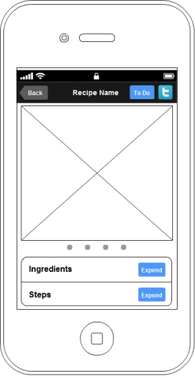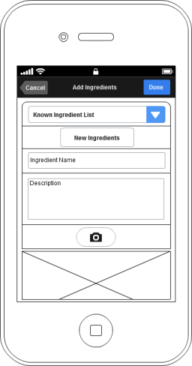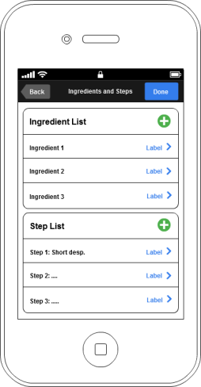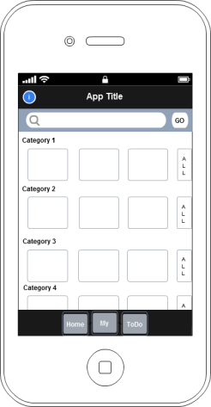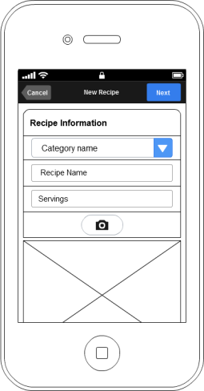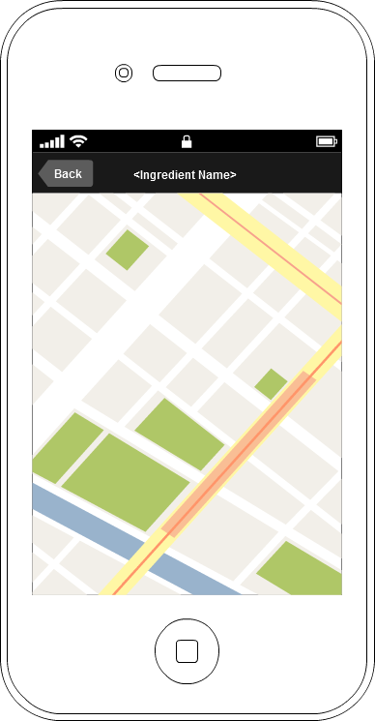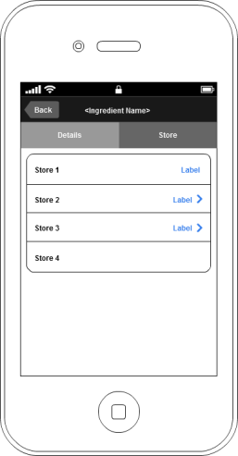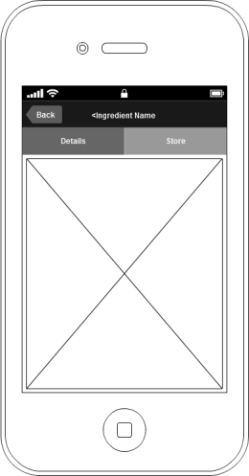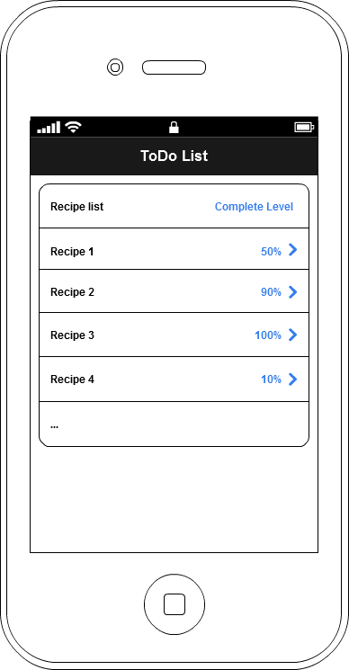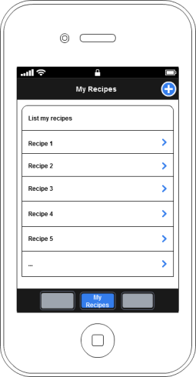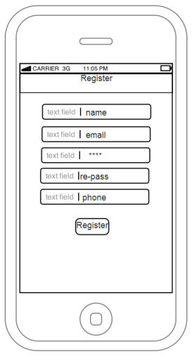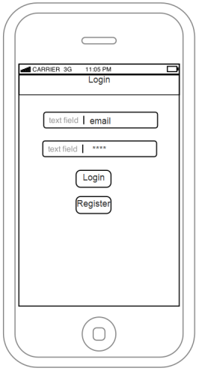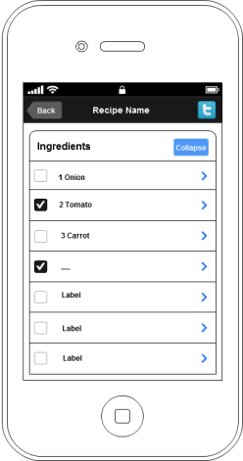

Ingredient page

(Details tab visible)

Recipe Ingredient/Step List

Add Step

Add Ingredient

Add New Recipe

ToDo Page

My Recipe Page

Main page

Register page

Login page

Map page

Ingredient page

(Store tab visible)

# Product Features/Requirements

## General Requirements

Programming Method:

* iOS Client: Objective C
* Server: PHP

## Functions/Features

### Login

***Description:***

The Login will display when the app is launched:

* Top bar with title
* Email text field
* Password field
* Login button
* Register button

***Wireframe:***

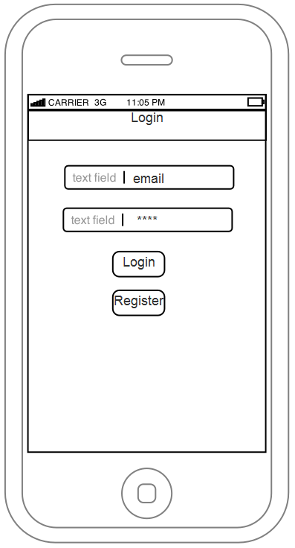

***Business rules:***

* Showing:
  + Email field contents a valid email
  + Password field
  + Login button will active validate form process and form value against the DB
  + Register button will direct user to register page.
  + If login successfully user will be direct to main page.

### Register

***Description:***

Register page allow new user fill the registration form.

* Username text field
* Email text field
* Password field
* Re-Password field
* Phone

***Wireframe:***

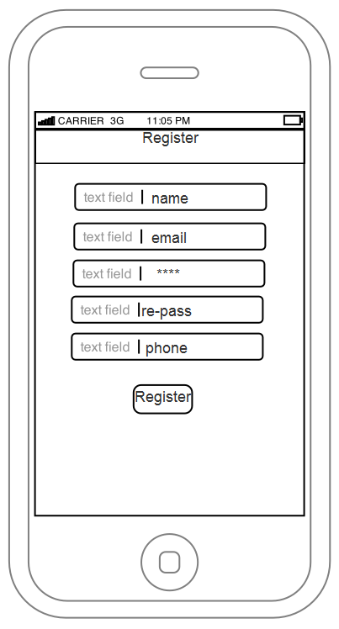

***Business rules:***

* Showing:
  + Name field, the user display name.
  + Email field, the email of user also act as the username for login.
  + Password, Re-Password must be the same.
  + Phone, user phone number.
  + Register button, will active the register process. First, it validate the user form value. If all valid, new user will be add to the DB.

### Main screen

***Description:***

The main screen consists of:

* Topbar with application title and add info button on the left.
* Search bar with button
* List of recipes thumb based on category
* All button for every category at the end of thumb list
* Tabbar with 4 buttons: Home, My Recipe, To-do and Feed

***Wireframe:***

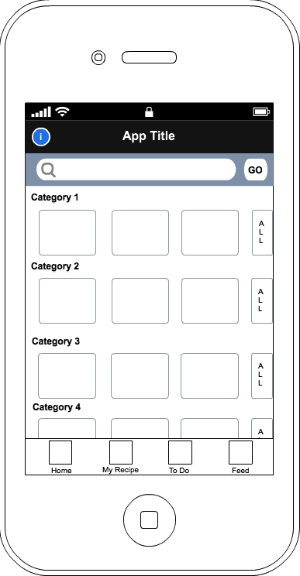

***Business rules:***

* Showing:
  + Search bar allow input name of user interested in recipe.
  + List of recipe will be pre-loaded with latest recipes from every category.
  + Select a recipe thumb on the list, user will be direct to the recipe page.
  + Tap on info button will popup the information slide about the application.
  + Home button on tab bar will display as default when the user login successfully.
  + My recipe button will direct user to my recipe page.
  + To-do button will direct user to recipe that they have been making.
  + Feed tab button will direct user to feed page
  + Each category will show the latest submitted recipe.
  + Every category has an all button at the end of latest recipe thumb list and when tap will direct user to the search page with predefine filter as the category
  + Tab bar dock at bottom screen and has auto hide function which reveal more space when in hidden mode (Every page has the same tab bar, if not, it must be in hidden mode)

### Search Result Page

***Description:***

The main screen consists of:

* Topbar with application title and the back button
* Search bar
* List of recipes

***Wireframe:***

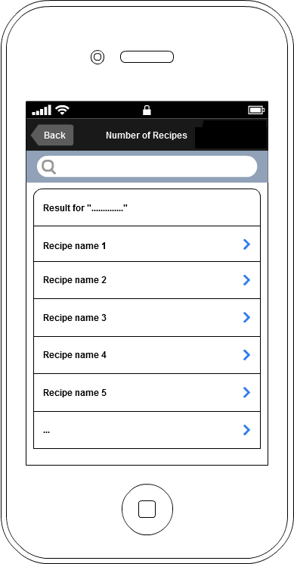

***Business rules:***

* Showing:
  + Tap on back button will direct user to the previous page.
  + Search bar allow input name of user interested in recipe.
  + List of recipe will be loaded base on the input keyword from users
  + Select a recipe on the list, user will be direct to the recipe page.

### To Do Page

***Description:***

The main screen consists of:

* Topbar
* List of recipes

***Wireframe:***



***Business rules:***

* Showing:
  + List of recipe will be loaded base on user’s recipe added for todo.
  + List also shows completion level on the right.
  + Tap on recipe item on the list will redirect user to the recipe page.

### Feed page

***Description:***

Feed page:

* Display newly created user’s recipes
* Display new recipes from others that the user following

***Wireframe:***

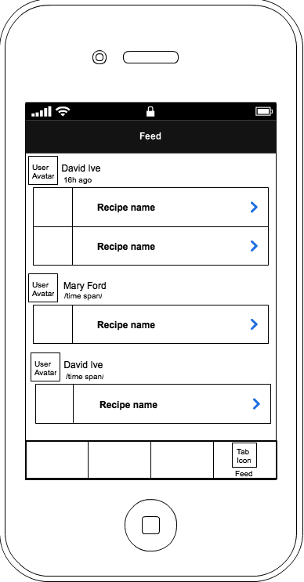

***Business rules:***

* Display a list of recipes grouped by their creator.
* Tap on a recipe item will bring user to recipe page.

### Recipe page

***Description:***

This page shows the details information about the recipe:

* At top, we add creator avatar and creator name.
* On the right, will be the LIKE button.
* At bottom, will show number of like and comments button for that recipe.
* Navigation bar with back button, Add to-do button and social sharing feature.
* A stack images for the recipe
* Ingredients label with expand button
* Steps label with expand button
* List of ingredients
* List of steps

***Wireframe:***

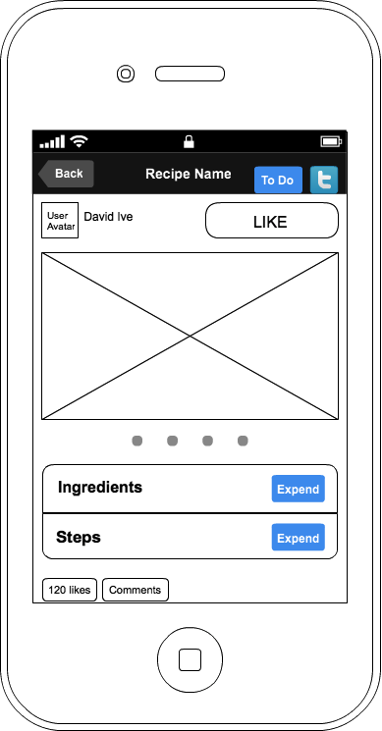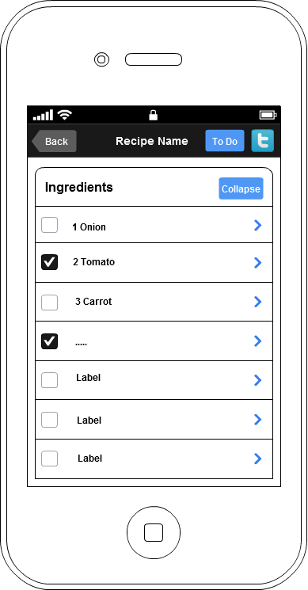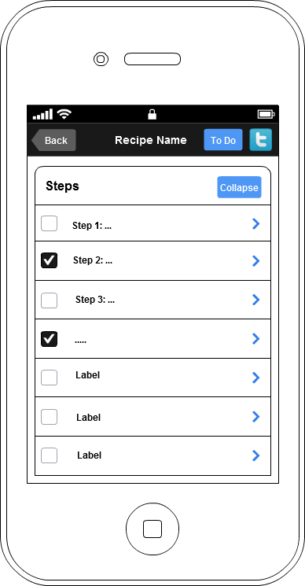

***Business rules:***

* Showing:
  + Tap on creator information will show the creator profile (user profile page).
  + LIKE button has 2 state LIKE and UN-LIKE
  + Tap on LIKE button; user will mark the current recipe as their favorite recipe. The number of like of that recipe will increase.
  + Tap on UN-LIKE button; user will remove the current recipe from their favorite recipe. The number of like of that recipe will decrease.
  + Like counter: show the number of users who like the recipe.
  + Tap on Comment will bring user to comment page for the recipe.
  + Tap back button on navigation bar will bring user to previous display.
  + Tap the todo button will show the check box and add the recipe to the todo list for later view.
  + Tap social network button will share/post the current recipe to the social network like facebook, twitter, or email it.
  + The stack images content some picture related to the recipe.
  + When swept on the current image, the picture will be change.
  + Tap on expend button on the ingredient list will show the list on the entire screen, over the image.
  + Tap on collapse button will collapse the list and show the picture.
  + Tap on an ingredient from the ingredient list will bring user to the ingredient details view.

### User Profile Page

***Description:***

Profile page show information of the selected user (creator of recipe). There are 2 sections:

* First, User Information is where display
  + User avatar
  + User name
  + Recipe button and number of user’s recipes
  + Follower button and number of follower
  + Following button and number of following user
  + The FOLLOW button.
* Second, show the list of 5 random chosen recipe of the user.

***Wireframe:***

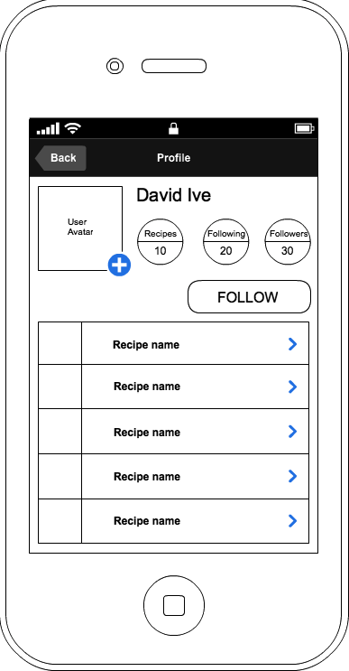

***Business rules:***

**Viewing other user profile:**

* FOLLOW button have 2 states:
  + FOLLOW state is active if the current user is not following this user. Tap on the button allow current user follow this user and the state of button change to FOLLOWING.
  + FOLLOWING state is active if current user already followed this user. Tap on the button allow user un-follow this user and the state of button change to FOLLOW.
* Tap on “Recipes” button will show the recipe list of user.
* Tap on “Following” button will show the list of users that the current user has been following.
* Tap on the Followers button show the list of users that follow the current user.
* List of random recipes from this user:
  + Tap on the recipe item will bring user to recipe page.

**Viewing my profile:**

* The title “/user name’s/ Profile” change to “My Profile”
* Button FOLLOW will be hidden
* On the avatar appear a small plus button, at the bottom right corner, allow user to change avatar.

### Following user list and follower list Page

***Description:***

Show the list of user that you are following or user that follow you

***Wireframe:***

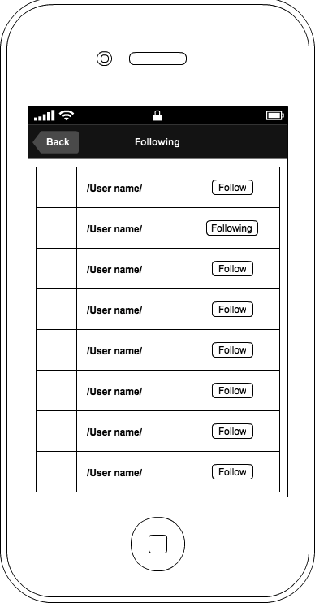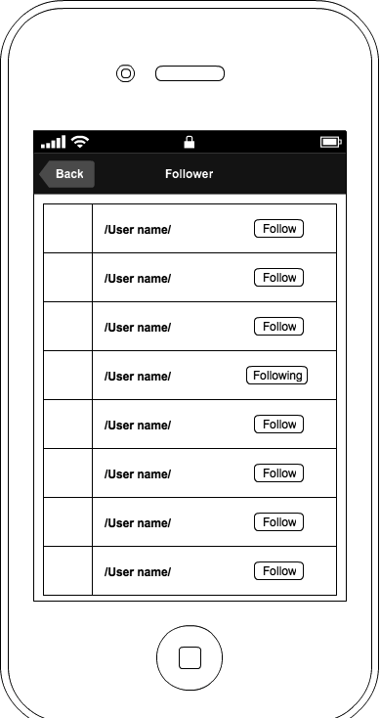

***Business rules:***

* Tap on user name will show user profile page
* Tap on follow button to follow.
* Tap on following button to un-follow.

### Comments Page

***Description:***

Show comments of the specific recipe with their avatar.

Allow users to submit their comment.

***Wireframe:***

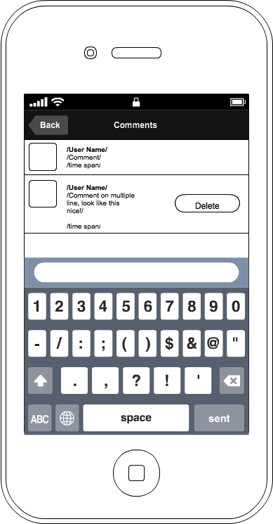

***Business rules:***

* Load the list of other user’s comment on the recipe.
* Type in the input box and hit sent to submit comment.
* When submit is commit, user able to delete the submitted comment by swept from right to left on the comment, a delete button will appear allow user to delete the comment.

### Ingredient Page

***Description:***

Ingredient page show 2 tab: pic tab and store tab

* Navigation bar with back button
* A view with 2 tab:
  + Pic tab: show the ingredient related image
  + Store: show the nearest store to get the ingredient

***Wireframe:***

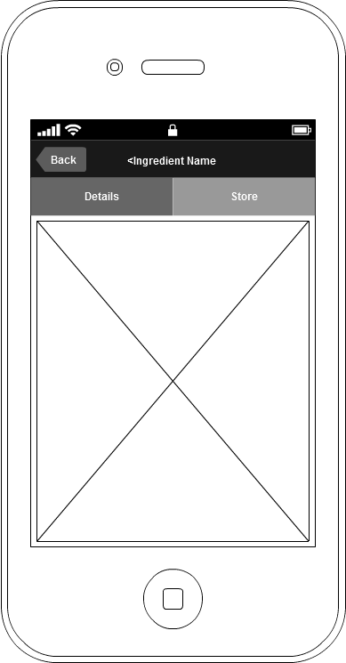

***Business rules:***

* Showing:
  + Tap on the back button of navigation bar will bring user to the previous view.
  + On the pic tab, tap on the pre-view picture the following action will trigger
    - The picture will be hidden or covered.
    - The description of the ingredient will be displayed on top of the picture.
    - Tap again on the description will undo the process: hide the description and show the picture.
  + On the store tap, a list of nearest will be display.
    - Tap on a store will bring user to the map, display the direction to the store from the phone location.

### Direction Page

***Description:***

This page contents a map with direction to the selected store from previous view.

* Navigation bar with back button
* A map view

***Wireframe:***



***Business rules:***

* Showing
  + Tap on back button on navigation bar will bring user back to previous view.
  + Map allows spanning and zooming to navigate the map easily.

### My Recipe Page

***Description:***

This page list the recipe posted by the user

* Navigation bar with plus sign button
* List of posted recipes

***Wireframe:***

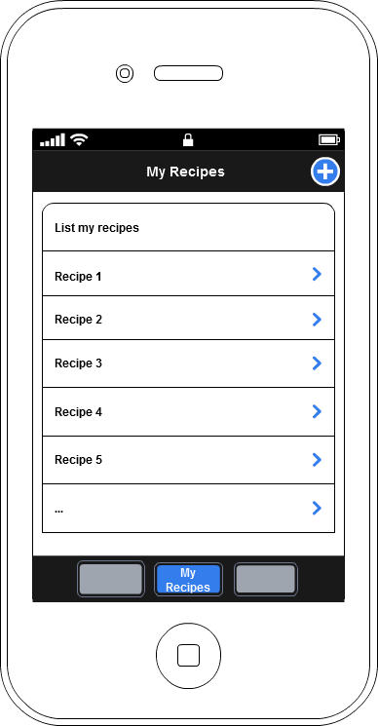

***Business rules:***

* Showing:
  + Tap on the plus sign button will bring user to the add new recipe page.
  + Tap on the list item have the same function as the list on homepage.

### Add New Recipe/Recipe Submit

***Description:***

This page allow user add their own recipe to the database. The page consists of:

* Navigation bar with 2 button: cancel and next
* Recipe name text field
* Serving number text field
* Dropbox category name
* Capture image button

***Wireframe:***

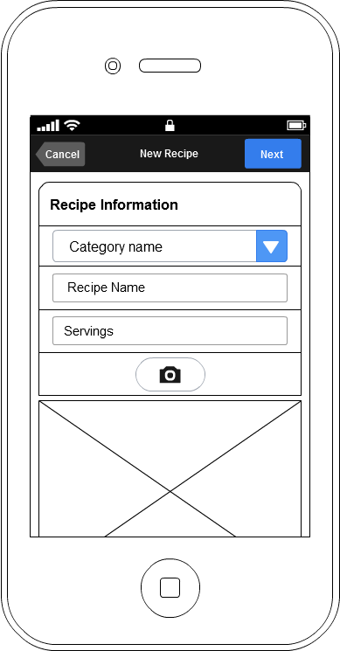

***Business rules:***

* Tap on cancel button, user will be back to the previous view and not submit the recipe
* Recipe name text field identify the name of the recipe
* Dropbox category name identify the category that the recipe belong to.
* Ingredient name text field identify component of the recipe
* Servings text field indentify the number of people can be serve
* Tap on the capture image to add photo to user recipe
* Tap on next button to save the new recipe to the database and user will be direct to add ingredient page

### ~~Recipe Ingredient and Step List~~

***Description:***

***This page will be remove because the new design don’t need to go to this step and it will reduce the deepness level of step to access add ingredient and add step page.***

This page allow user add their own recipe to the database. The page consists of:

* Navigation bar with 2 button: cancel and done
* List of recipe ingredients with plus sign button for add more ingredients
* List of recipe steps with plus sign button for add more steps

***Wireframe:***

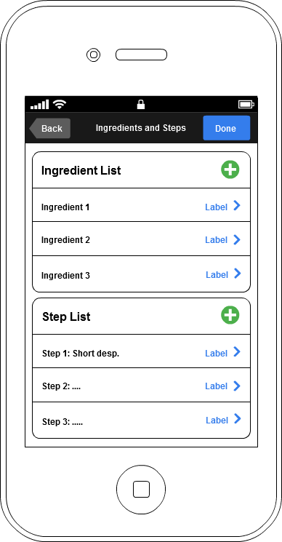

***Business rules:***

* Tap on back button, user will be back to the previous view
* Tap on the list item will have the same function as the list of home page.
* Tap on the plus sign buttons will direct user to the add ingredient page or add step page
* Tap on the done button will bring the user to my recipe page

### Add Ingredient

***Description:***

This page allow user add their own recipe to the database. The page consists of:

* Navigation bar with 2 button: cancel and done
* Ingredient dropdown list
* Ingredient name text field
* Ingredient description text field
* Capture image button

***Wireframe:***

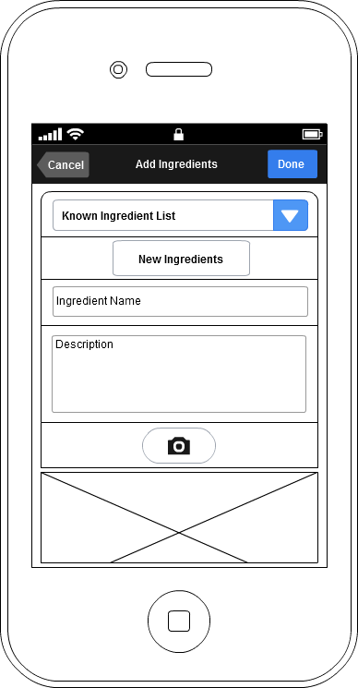

***Business rules:***

* Tap on cancel button, user will be back to the previous view and not submit the recipe
* Ingredient dropdown list allow user add predefined ingredient and not add the new ingredient
* Ingredient name text field identify component of the recipe
* Ingredient description text area for input more details
* Tap on capture image button to add photo to the ingredient
* Tap on done button to save the new ingredient to the database and user will be direct to ingredient list

### Add Step

***Description:***

This page allow user add their own recipe to the database. The page consists of:

* Navigation bar with 2 button: cancel and done
* Short description/Name text field
* Description text area
* Note text area (optional)
* Capture image button

***Wireframe:***

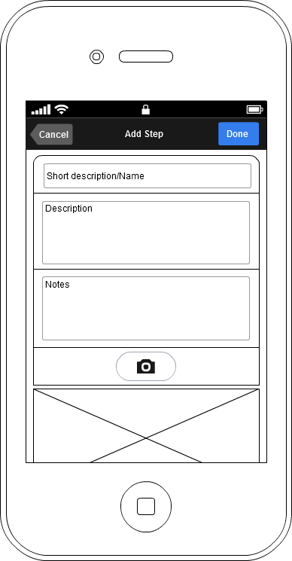

***Business rules:***

* Tap on cancel button, user will be back to the previous view and not submit the recipe
* Short description/ name text field used to display name of the step
* Description text area will content main how-to step
* Note text area will content additional information
* Tap on capture image button to add photo to the ingredient
* Tap on done button to save the new step to the database and user will be direct to ingredient and step list

### Web Administration

***Description:***

The web admin host a number of services used by the iphone.

Hosted services:

* Login service
* Register service
* Search service
* Recipe service
* Ingredient service
* Recipe sharing service
* Store service
* Tracking service
* Add user recipe

Management functions:

* Manage users
* Manage stores
* Manage recipes
* Manage ingredients

Front-end CMS:

* Introduction page

***Business rules:***

Hosted services:

* Login service allows validate input data from iphone login page
* Register service allows validate and add user from data of iphone register page
* Search service allows perform the search feature of main page.
* Recipe service allows load the specific recipe from the database requested by iphone user
* Ingredient service allows load the specific ingredient requested
* Recipe sharing service allows post/or email the selected recipe to the social network
* Store service allows load a list of nearest store of an ingredient based on iphone location.
* Tracking service allows record the user behavior.
* Add user recipe allows user add new recipe to the database thought iphone app.

Management functions:

* Manage users:
  + List of user: provide a view of list of all the registered user
  + Sorting and filtering user based on a specific criteria
  + Ban or delete user
* Manage stores:
  + List of store: provide a view of all store currently available
  + Input new store allows add a new store to the database
  + Update store information page
* Manage recipes:
  + List of recipe: provide a view of recipe list.
  + Sorting and filtering store based on specific criteria such as recipe by user, has the ingredient, from the store…
  + Upload image function
* Manage ingredient:
  + List of ingredient: list the entire ingredients posted by user.
  + Update ingredient information page
  + Upload image function

Front-end CMS:

* Introduction page:
  + Front-page contents image, article, movie about the application.
  + Contact information